Mechanical Design Progress Report

Industrial Sorter Project

Cody Birkland, Sensor Team, EWU IEEE Student Chapter

August 16, 2020

Problem:

For our industrial sorter, the initial mechanical design was found to have restrictions at all the Skittle passageways. The radius of these parts was too small for the objects to reliably pass through. This is inhibiting us from building a working mechanical prototype, as the candies would consistently jam at all pass-through locations. In order to have formal tests of our existing motor controller and color sensor, we need working mechanical parts, namely the sensor mount, transport cups, and the funnel/metering assembly.

Research:

Significant statistical analysis was done by Matt and Michael. For now, the dataset was utilized to obtain the maximum expected diameter and height of the product. With the large dataset, it was concluded with confidence that a height of 10mm and a diameter of 15mm would be conservative.

Action:

The Transport Cup Inserts were modified to have a lower diameter of 15mm.

The Funnel Adapter, Funnel, and Metering Plate bores were also widened, but the part walls also had to be thickened to preserve the structural integrity of the parts.

Having decent parametric drawings (3D objects all defined by dimensionally-constrained 2D drawings) made this relatively simple – changed sketch dimensions and all derived components automatically updated (funnel, metering plate, funnel adapter, etc)

Sketch Objects (a little messy)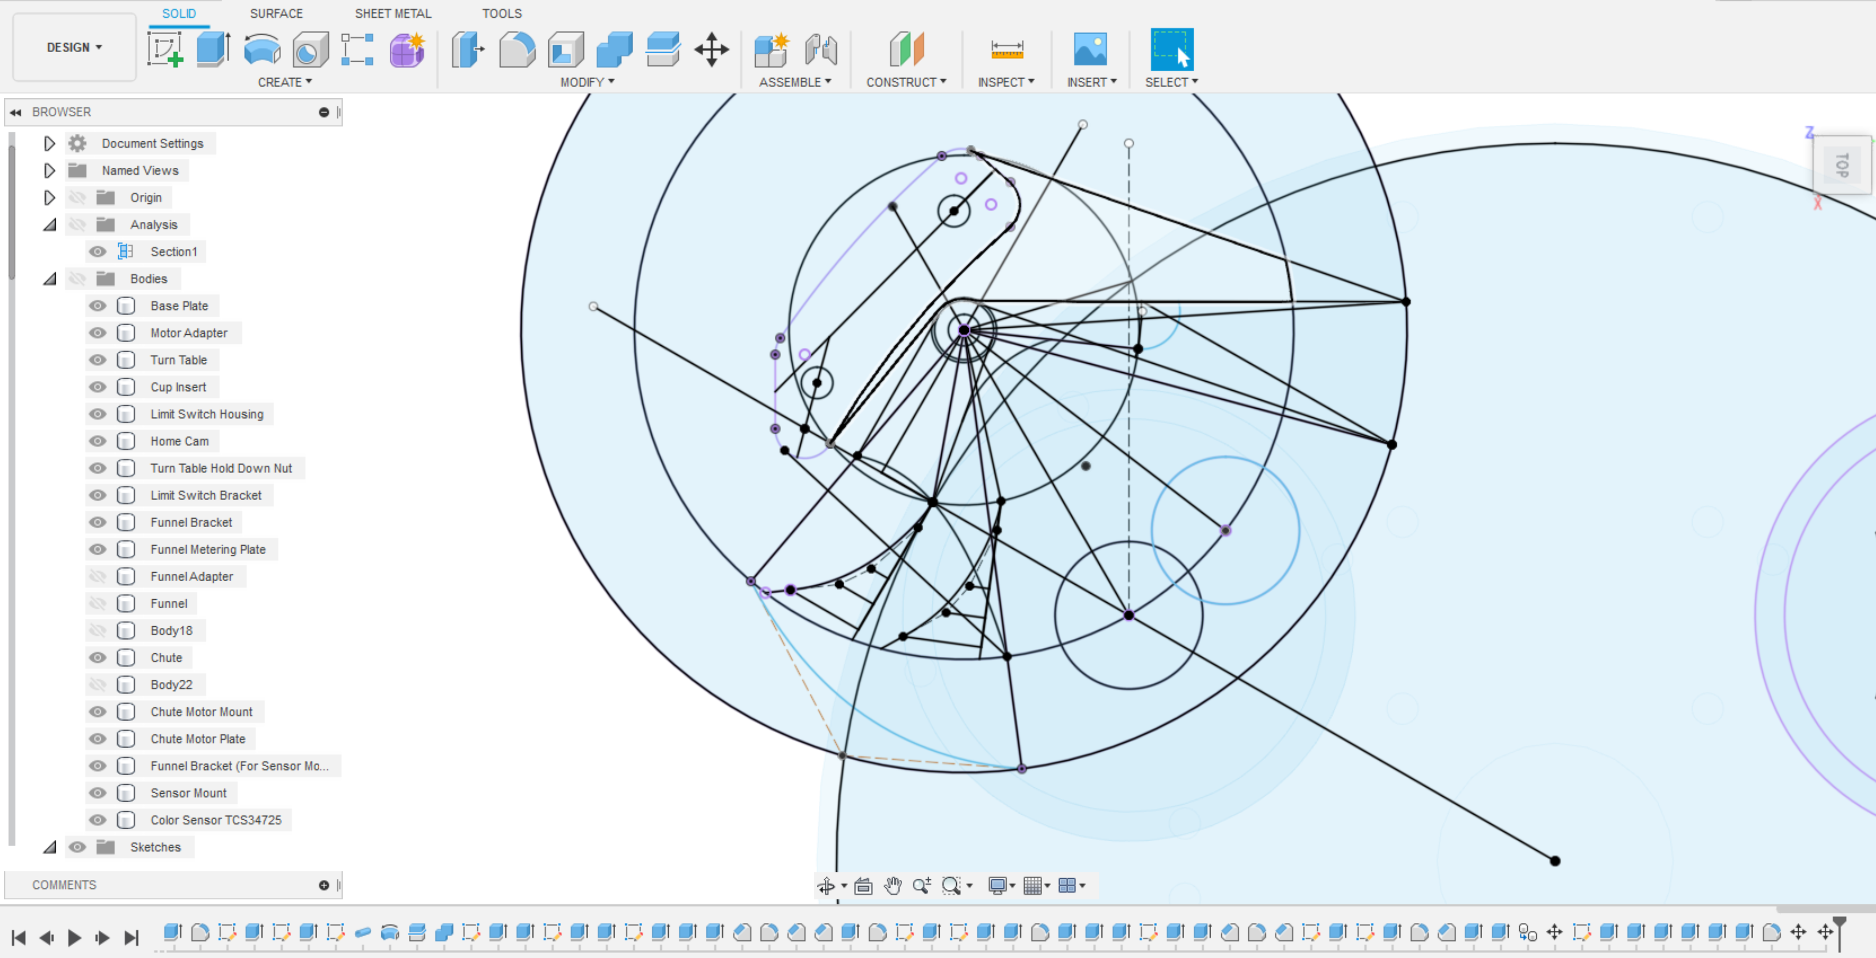

Derived Objects (Funnel Metering Plate)

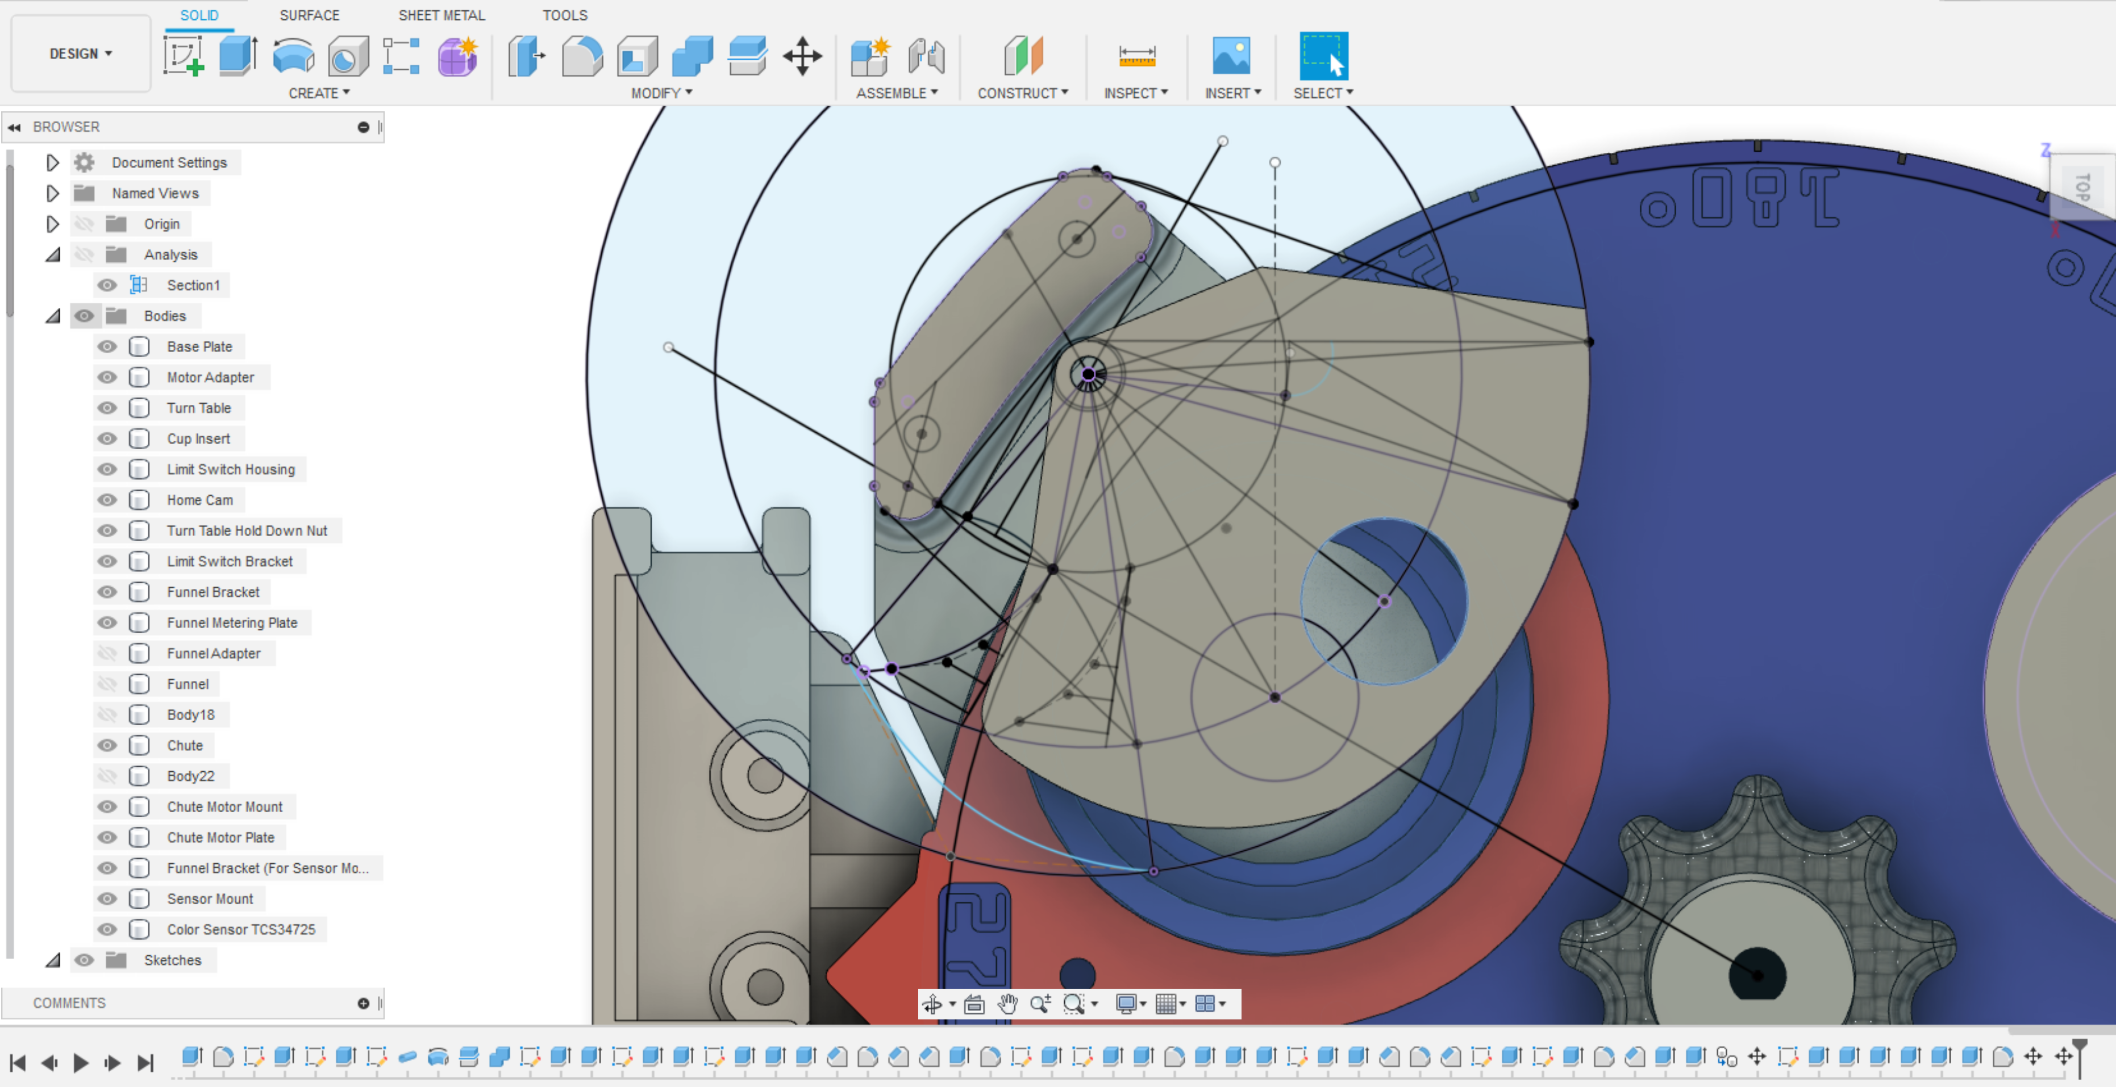

Value:

Modifying these objects, as well as a few improvements to the funnel system and creating the sensor mount (mostly a copy of the funnel mount), now enables us to do real-condition testing of the color sensor and rotary table. With the successful sensor to motor interface bench test earlier this week, this means that we are very close to have a complete mechanical path from product staging at the funnel to sorted product at the output of the chute. Printing and assembling the parts built here will represent a major step towards our goal of having a completed mechanical assembly by the end of August. The remaining mechanical parts are the framework, sensor curtain, and electrical cabinet. If testing of these parts goes well, we will be significantly ahead on our development. We’ll have time to refine the design, increase reliability, and add additional features.